TBI AP to PA Procedure
Written by: Cassidy Northway
Date: 20/05/2025

- In ECLIPSE, EXPORT desired CT Series
- Open 3D Slicer, load in DICOM data
  - 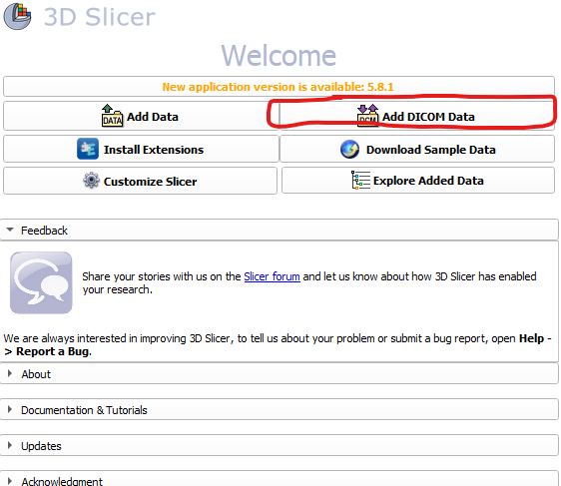
  - 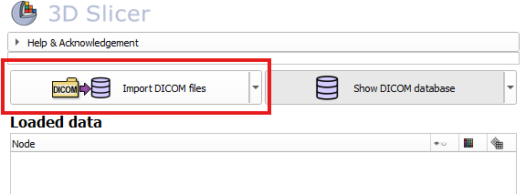
  - Navigate to folder with CT series data, load
  - 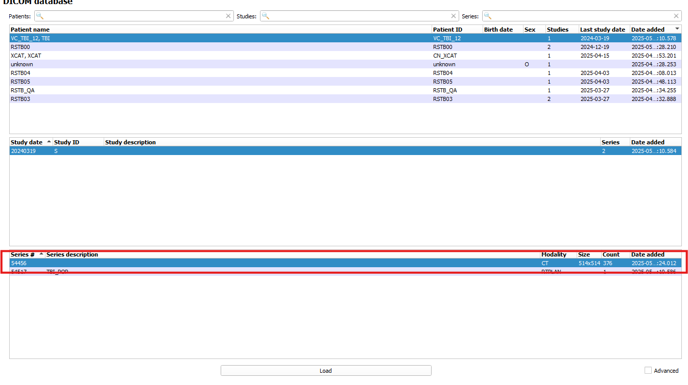
- Once volume is opened in 3D Slicer check it looks appropriate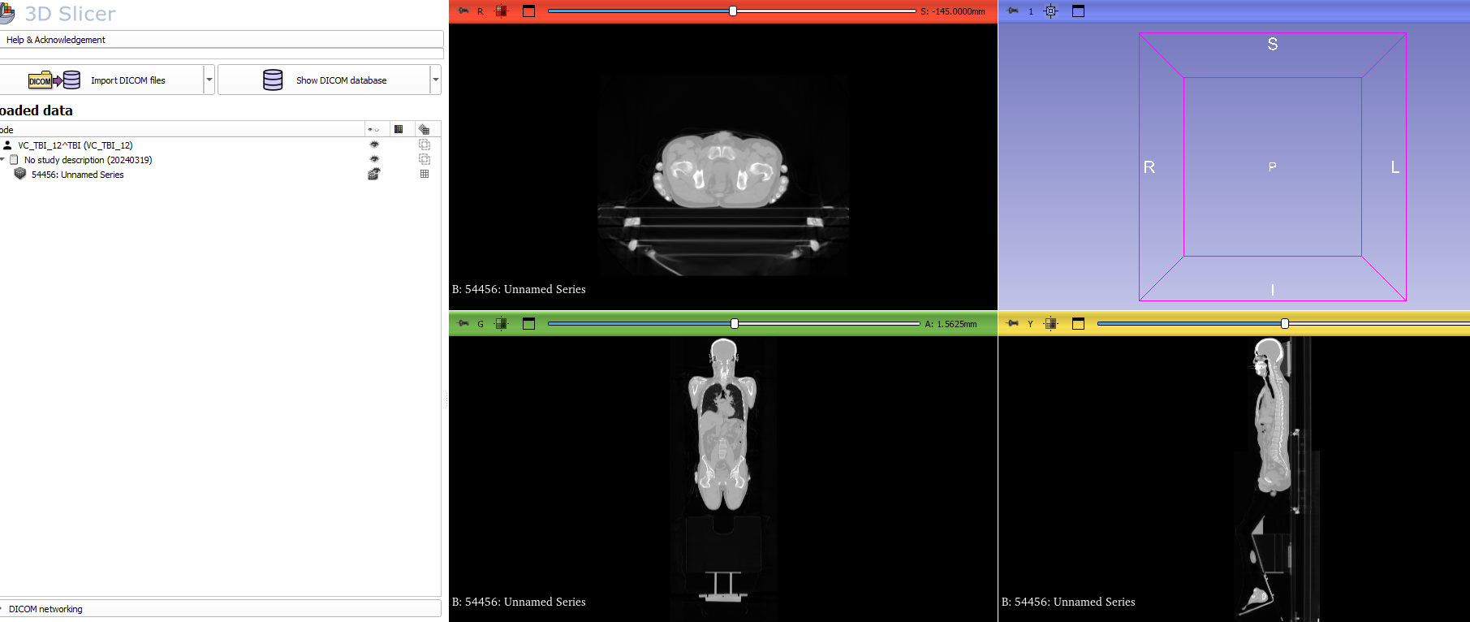
- Navigate to the modules at top, Converters and then Create DICOM Series 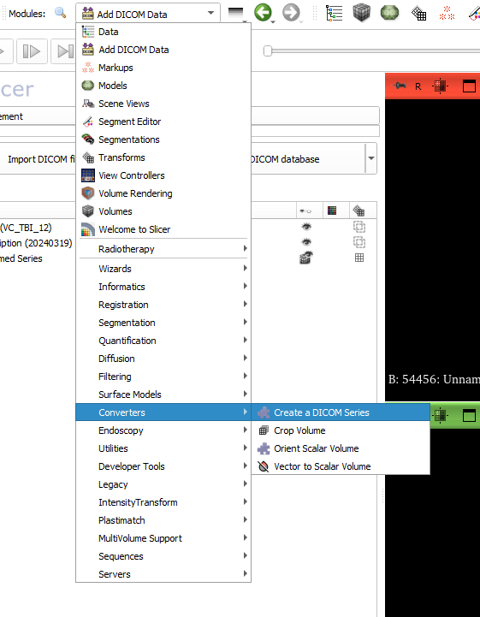
- Select the volume you want to flip, select your DICOM Output Directory and fill in the patient, study and series parameters to your satisfaction and select HFP in Series Parameters. Select Apply
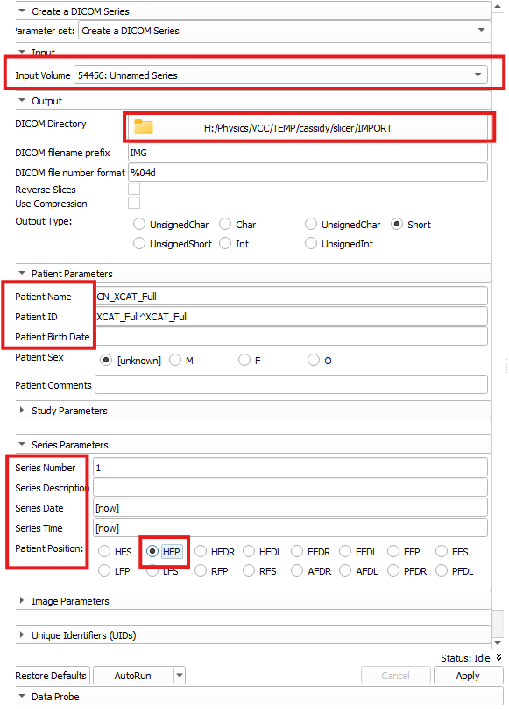
- Import the flipped patient to Eclipse!

